Home Improvements That Matter
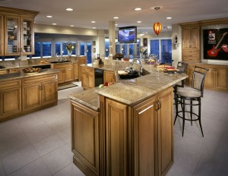
Making home improvements not only creates beautiful upgrades to your home but can also increase its overall value. Some of these improvements will increase the value of your home, and some will actually make selling more difficult. Here is how to tell the difference.

Projects With the Highest Resale Value
Updated homes frequently sell faster. Here is the list of highest resale upgrades:
- Kitchens – people want modern conveniences and style
- Bathrooms – modernizing results in good returns
- Outdoor improvements – first impressions happen quickly
- Roofs and windows – buyers expect these to be in good condition

Projects That Can Negatively Affect Resale Value
Updates that are of a personal nature are less likely to have a positive effect on resale value. Here is the list of top projects that may impact resale value negatively:
- Luxury upgrades – mid-range upgrades have a better return
- Rooms that do not fit with the floor plan – converting a patio to a sun room can deter potential buyers
- Garage conversions – buyers like garages
- Swimming pool – often seen as a safety hazard

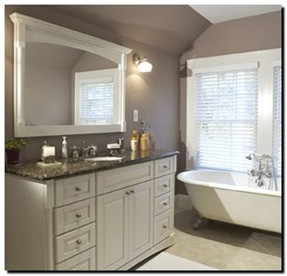
Tip #3
Adding a deck increases the value of your home. Outdoor living spaces have become more desirable, especially since more people stay home for vacation. If you make your deck and your backyard more appealing, your house will be more appealing to prospective buyers when you decide to sell. HGTV claims that homeowners recoup 65%-90% of their investment by adding a deck.

Tip #4
Thinking of updating your home with one of these home improvements and wondering how long they generally last?
new chimney: 100 years or more
asphalt shingles: 15 to 30 years
a wooden deck: 15 years
ceramic tile or terrazzo: 100 years or more
vinyl flooring: 20 to 30 years
oak or pine floors: 100 years

Tip #5
Planning to buy new appliances? Here's how long they generally last.
new chimney: 100 years or more
asphalt shingles: 15 to 30 years
a wooden deck: 15 years
ceramic tile or terrazzo: 100 years or more
vinyl flooring: 20 to 30 years
oak or pine floors: 100 years

